Protocol for Monitoring Aquatic Invertebrates at Ozark National Scenic Riverways, Missouri, and Buffalo National River, Arkansas. Heartland I&M Network and Prairie Cluster Prototype Monitoring Program

SOP 5: Measuring Stream Discharge

Version 1.1 (08/10/2018)

Revision History Log:
Previous Version # | Revision Date | Author | Changes Made | Reason for Change | New Version #
1.0 | 10 Aug 2018 | Bowles | Minor edits | Updates based on DeBacker et al. (2012) | 1.1
1.0 | 10 Aug 2018 | Bowles | HACH 950 added | New technology | 1.1
1.0 | 10 Aug 2018 | Bowles | Calibration section removed | Refers to stand alone lab guide for calibration and maintenance. | 1.1

This SOP is guidance for measuring discharge in rivers and streams, specifically in the Ozark Highlands area. This guidance is for using the FLO-MATE 2000 (Marsh-McBirney, Frederick, Maryland) and HACH FH950 flow meters, although the SOP is generally applicable to other types of meters as well (e.g., Price AA, pygmy meters). This SOP describes sampling procedures. Standard proceedures for operating, calibrating, maintenance and storage of the flow meter can be found in the manufacturer’s operations manuals, and the HTLN lab guide. If other meters are used, field personnel should review the instruction manual for instrument-specific guidance on how to calibrate and operate those particular meters. Discharge is manually measured only for sites not having a USGS gage nearby or located immediately upstream (e.g., tributaries). All other discharge measurements are taken from USGS gages (Table 1).

- Background Information

Velocity and depth are measured using a current meter attached to a wading rod. The rod allows for quick and easy measurements of depth with incremental markings and an adjustable arm that places the current meter at the proper depth for measuring velocity (60% of the depth from the surface of the water). Some current meters have rotating cups (Pygmy and Price models) while others have a pair of electronic contacts on a small head (FLO-MATE 2000, FH950) to measure velocity. Such sensors are equipped with an electromagnetic coil that produces a magnetic field. A pair of carbon electrodes measure the voltage produced by the velocity of the conductor, which in this case is the flowing water. Internal electronics process measured voltages and output them as linear measurements of velocity. Velocity is displayed as either feet per second or meters per second.

Stream discharge (Q) is the volume of water passing a cross-section per unit of time and is generally expressed in cubic feet per second (ft³/s) or cubic meters per second (m³/sec). Discharge is estimated by multiplying current velocity by the cross-sectional area (Carter and Davidian, 1969). Cross sectional area is determined by first measuring the width of the stream channel. The cross section is then divided into smaller increments (usually 15 to 20 intervals) and depth and velocity are measured at each increment. The depth and width of the interval are multiplied to get an area for each interval and then each interval area and velocity is multiplied to produce a discharge for each interval. These discharges are summed to produce a total discharge for that cross section of the stream. This process will be described in greater, step by step detail in the “Procedures” section.

II. Prior to the Field

Equipment List

- FLO-MATE Model 2000 (Marsh-McBirney) velocity meter, or HACH FH950 velocity meter
Accuracy of ±2% operates in temperatures between 0°C and 72°C.
- Tape measure (in increments of feet and/or meters)
- Stakes for mounting tape measure if necessary
- Top-setting wading rod (in increments of feet or meters)*
- 3-5 gallon bucket
- Extra batteries
- Carrying case
- Log book
- Data sheets on waterproof paper
- Instruction manual

*Standard wading rods come in both metric and English standard units (feet). Discharge measurements are generally recorded in English units as cubic feet per second. Whatever units are used, ensure that there is consistency between the settings on the velocity meter, the wading rod, and the tape measure and that the units are clearly recorded on the data sheet. English standard units are easily converted to metric units when required.

III. In the Field

Discharge measurements should be made after other measurements such as temperature, dissolved oxygen, pH, and conductivity are complete. Discharge measurements require wading across the stream and may stir-up sediments, disrupting accurate measurement of other parameters. Discharge at both BUFF and OZAR is physically measured only for tributaries.

Under normal flow conditions, discharge using the methods outlined below cannot be used for most mainstem sampling sites. Attempting to obtain a discharge measurement at these sites poses a significant safety risk for personnel. To obtain an approximate measure of discharge at mainstem sampling sites, the mean daily discharge recorded at the USGS gaging stations will be used (SOP#1). For CURRM06, a more accurate estimate of discharge can be obtained by adding the discharge at Big Spring to the daily mean discharge recorded at the Van Buren gaging station.

Table 1. USGS staff gages at BUFF and OZAR used for making discharge estimates for monitoring sites.
Monitoring Site | Gage  Name | Gage Number | URL
Buffalo National River
BUFFM01 | Boxley | 7055646 | http://waterdata.usgs.gov/ar/nwis/uv?site_no=07055646
BUFFM02 | Pruitt | 7055680 | http://waterdata.usgs.gov/ar/nwis/uv?site_no=07055680
BUFFM03 | Pruitt (plus Big Creek) | 7055680  7055814 | http://waterdata.usgs.gov/ar/nwis/uv?site_no=07055681  http://waterdata.usgs.gov/ar/nwis/uv?site_no=07055814
BUFFM04 | St. Joe | 7056000 | http://waterdata.usgs.gov/ar/nwis/uv?site_no=07056000
BUFFM05 | St. Joe | 7056000 | http://waterdata.usgs.gov/ar/nwis/uv?site_no=07056000
BUFFM06 | Harriett | 7056700 | http://waterdata.usgs.gov/ar/nwis/uv?site_no=07056700
BUFFT20 | Bear Creek | 7056515 | http://waterdata.usgs.gov/ar/nwis/uv?site_no=07056515
Ozark National Scenic Riverways
CURRM01 | Montauk State Park | 7064440 | http://waterdata.usgs.gov/mo/nwis/uv?site_no=07064440
CURRM02 | Akers | 7064533 | http://waterdata.usgs.gov/mo/nwis/uv?site_no=07064533
CURRM03 | Akers | 7064533 | http://waterdata.usgs.gov/mo/nwis/uv?site_no=07064534
CURRM04 | Van Buren | 7067000 | http://waterdata.usgs.gov/mo/nwis/uv?site_no=07067000
CURRM05 | Van Buren | 7067000 | http://waterdata.usgs.gov/mo/nwis/uv?site_no=07067000
CURRM06 | Van Buren (plus Big Spring) | 7067000, 7067500 | http://waterdata.usgs.gov/mo/nwis/uv?site_no=07067000; http://waterdata.usgs.gov/mo/nwis/uv?site_no=07067500
JACKM01 | Mountain View | 7065200 | http://waterdata.usgs.gov/mo/nwis/uv?site_no=07065200
JACKM02 | Mountain View | 7065200 | http://waterdata.usgs.gov/mo/nwis/uv?site_no=07065200
JACKM03 | Mountain View | 7065200 | http://waterdata.usgs.gov/mo/nwis/uv?site_no=07065200

Quantitative Discharge Procedure:

    - Prior to taking any measurements, the location where discharge will be measured must be determined. An ideal cross-section in the sample reach will have the following qualities:
- The stream channel directly above and below the cross-section is straight.
- There is measurable stream flow, with a stream depth preferable greater than 10 cm and velocities generally greater than 0.15 meter/second.
- The streambed is a uniform “U” shape, free of large boulders, woody debris, and dense aquatic vegetation
- The stream flow is laminar and relatively uniform with no eddies, backwaters, or excessive turbulence.
Note: The cross section will not likely meet all these qualifications
but the best location should be selected based on these standards.
Record (and/or draw a diagram) on the data sheet a description of
any discrepancies with the cross section.
    - Once the cross section is established, measure the width of the stream with a tape measure to the nearest 0.1 meter and secure the tape across the stream for the duration of the discharge measurement.
    - Divide the stream into equal intervals across the width of the cross section, usually 15 to 20. A minimum of 10 intervals is recommended. A velocity and depth measurement will be recorded for each interval across the stream at the center of each interval. For example, if the stream is 10 meters wide, 10 velocity and depth measurements will be taken at one meter intervals. The first measurement will be taken a half foot from the water’s edge, the second 1 and a half feet from the water’s edge, etc., as shown in Figure 1.
    - Turn the current meter on (ON/C) and check to ensure that the velocity units coincide with the measuring tape and wading rod units. For FLO-MATE 2000, set the meter to FPA with 20-second intervals.
    - Attach the sensor to the wading rod and ensure that the sensor is securely screwed onto the rod and facing upright.

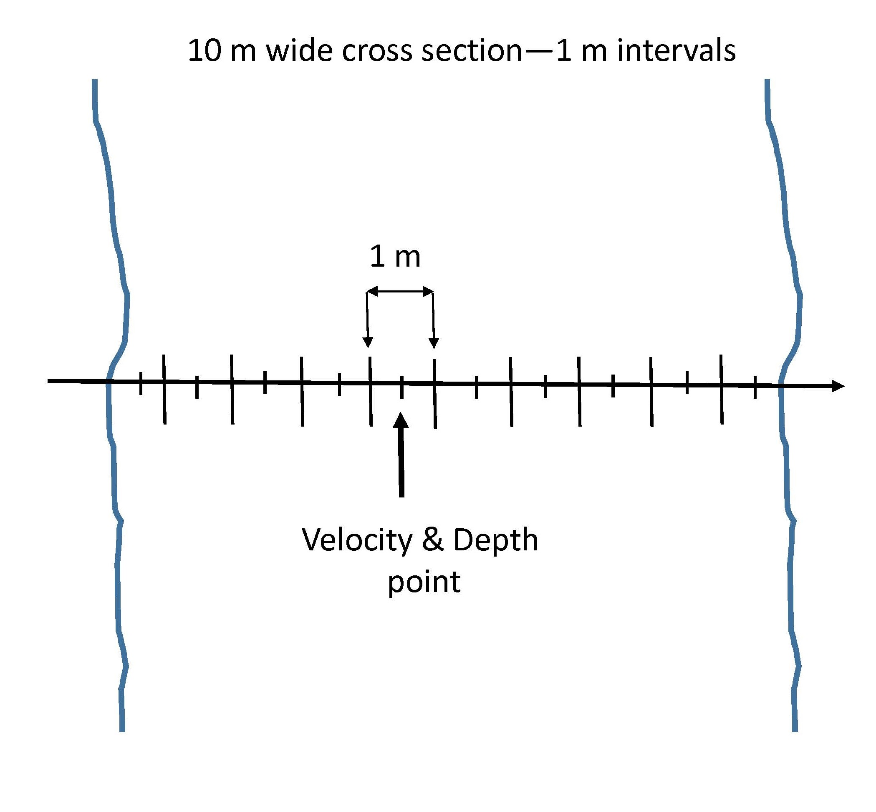

Figure 1. Cross section diagram.

    - One person should record discharge and one person should remain on the bank, recording data. Start at the water’s edge and move to the center of the first interval. Place the wading rod as level as possible and hold perpendicular to the water level. Read depth from the wading rod to the nearest centimeter. The rod will have graduated marks along its length, with single marks indicating two centimeters, double marks indicating 10 centimeters, and triple marks indicating one-half meter increments.
    - Once depth has been read, adjust the arm of the sliding rod with the sensor attached to 60% of the water depth. The wading rod will place the sensor at 60% of the depth from the surface of the water when properly adjusted.
Note: For example, if the depth is 2.6 meters, line up the 2 on the meter scale (sliding rod) with the 6 on the tenth scale (increments on handle of fixed rod). The sensor is now located at 60% of the water depth.
    - Stand behind the sensor and make sure there is no disturbance (including the senor cord) around the sensor that interferes with the velocity measurement. The meter may be adjusted slightly up or downstream to avoid boulders or other interferences.
Note: Make sure the sensor directly faces the flow of the water. This may not always be directly parallel with the water’s edge, the rod and sensor may need to be turned slightly with each measurement.
    - Allow the instrument enough time to get an accurate reading, generally around a minute. Watch the time bar complete two full cycles and then take the velocity reading. If something happens during the measurement, such as accidental movement of the wading rod, the meter can be cleared and the reading started again by hitting ON/C.
    - Call out the distance from the water’s edge, the depth, and then the velocity to the person recording data. Continue moving across the stream until measurements have been taken at all intervals.
Note: If the water velocity increases greatly between intervals, additional measurements can be taken to shorten the width of the intervals within this area of high velocity. Be sure to change the interval width for these measurements in the calculation of discharge.
    - When finished, detach the sensor from the wading rod and place it back in the mesh side pocket for transportation. If you do not expect to use the meter for several days, turn the meter off, clean the sensor, and store properly.
    - Change batteries when the low battery flag is displayed. The battery compartment is located in the bottom of the meter. Remove the instrument from its carrying case and install two batteries as described in the meter preparation procedures.
    - When storing the meter, clean and dry the sensor probe and cable, role the cable up and place both the cable and probe in the mesh pocket of the carrying case. When storing the meter for a period of more than two weeks, remove the batteries.
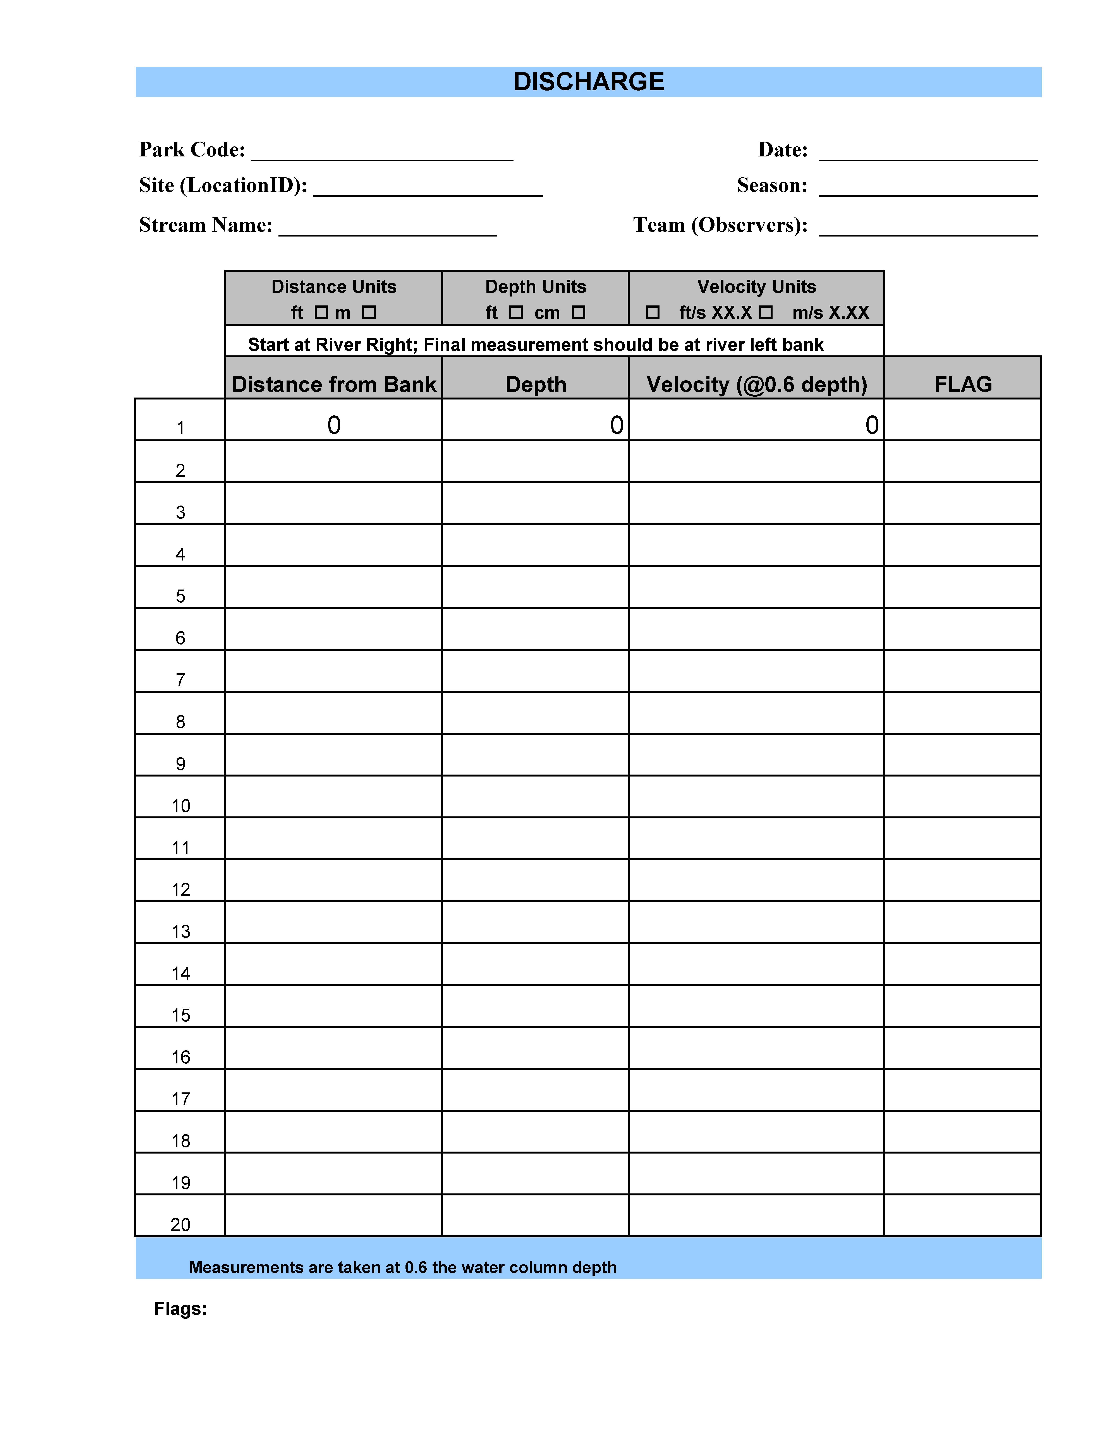

- Reference

Carter, R.W., and J. Davidian. 1969. General procedure for gaging streams. Book 3, Chapter A6 of Techniques of water-resources investigations of the United States Geological Survey. United States Government Printing Office, Washington, DC.

